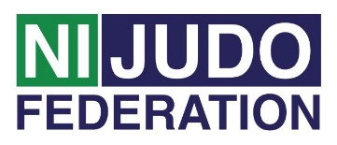
Volunteer Role Description — Chairperson

Chairperson Main role:
♦ Be well aware of all current and future club activities
♦ Chair the club committee meetings and club AGM

Tasks involved:
♦ Lead, but does not direct
♦ Ensure there is fair discussion on each issue and that all points are expressed before a decision is reached
♦ Keeps the meeting moving in the desired direction. Be firm, but tactful, with members deviating from the point under discussion
♦ After adequate discussion on an issue impartially summarises the points of view expressed, both for and against, to make sure members know clearly what they will be voting or agreeing to
♦ Runs the meeting so that a balance is struck between speed and efficiency on the one hand, and keeping the meeting enjoyable on the other
♦ Start meetings on time
♦ Know and follow the agenda strictly, unless directed otherwise by the meeting
♦ Attempt to get all members to contribute to the meeting
♦ Be enthusiastic
♦ Ensure Club Committee Members fulfil their responsibilities to assist in driving club development plan forward
♦
Accountability:
♦ The Chairperson is accountable to all the members and the club committee

Support and training:
♦ The Northern Ireland Judo Federation Volunteer Co-ordinator will be available to
provide support to all volunteers. This can be on a formal or informal basis as
required.

Expenses and equipment:
♦ This is a voluntary post and therefore no payment will be received, on occasion
mileage may be provided if the volunteer is asked to travel further afield.
♦ The Volunteer Co-Ordinator can advise volunteers on the types of expenses that
may be covered.

Vetting:
♦ As Chairperson you more than likely not to have access to children/young people or vulnerable adults within the club as part of your role and therefore a Disclosure & Barring Service (DBS) check (enhanced ) will not be required. If you are involved in a coaching role this may change, please check with your club.

