Volunteer Role Description
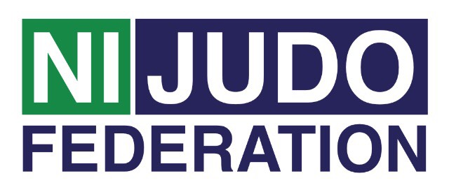
First Aider
First Aider Main role:
- To be the nominated First Aider for the club, to keep up to date with first aid training, using an Automated External Defibrillator (AED)
- To administer basic first aid to club members at the training, competition venue if required
- To provide immediate lifesaving and medical care if required before an Ambulance arrives
- To record any administration paperwork and store appropriately

Tasks involved:
- Manage the incident and ensure the continuing safety of themselves, bystanders and the casualty.
- Assess casualties and find out the nature and cause of their injuries
- Arrange for further medical help or other emergency services to attend (eg: the fire service)
- If trained, prioritise casualties based upon medical need
- Provide appropriate first aid treatment as trained
- If able, make notes, observations of casualties
- Fill out any paperwork as required
- Provide a handover when further medical help arrives
- Ensure the First aid supplies are replenished after an incident/accident

Time and location:
The club runs weekly on (Insert)……….… from (Insert) until (Insert) at ..(Insert)

Support and training:
- The First Aider will receive support from the club. Northern Ireland Judo Federation Volunteer Co-ordinator will be available regularly to provide support to all volunteers. This can be on a formal or informal basis as required.
- A variety of training courses will be on offer throughout the year. Some of the courses will be mandatory for all volunteers to attend, such as;
- Volunteer Induction
- Inclusive Training
- Safeguarding Training - Children & Vulnerable adults
- Other courses will be available dependent on the volunteer’s stage of development and requirements for their role.

Expenses and equipment:
- This is a voluntary post and therefore no payment will be received, on occasion mileage may be provided if volunteer is asked to travel further afield.
- The Volunteer Co-Ordinator can advise volunteers on the types of expenses that may be covered.

Vetting:
- Depending on the frequency of this Volunteer Role as First Aider you may be subjected to a Disclosure and Barring Service (DBS) check as you may be in a regulated position. Information will be provided to you if this is the case.

