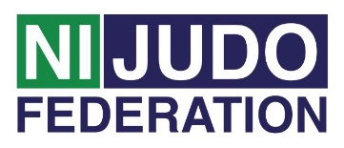
Volunteer Role Description - Head Coach

Head Coach Main role:
♦ To ensure the smooth running of the club by maintaining high standards of coaching and safety within the club

♦ To prepare and deliver club’s coaching sessions to members and support assistant coaches

♦ To commit to developing their coaching knowledge and skills

Tasks involved:
♦ Prepare the venue for the session and to clear the venue at the end of the session, assistance may be given by assistant coach and support helpers;
♦ Follow all policies and procedures including the Code of Conduct for Coaches and support the participants to understand the policies and procedures as they apply to them;
♦ To undertake training appropriate to this role e.g. Safeguarding Children and Young People in Sport Awareness. First Aid qualification.

Time and location:
♦ The club runs weekly on (Insert)……….… from (Insert) until (Insert) at ..(Insert)

Support and training:
♦ Head Coach will receive support from the club committee. Northern Ireland Judo
Federation Volunteer Co-ordinator will be available regularly to provide support to all
volunteers. This can be on a formal or informal basis as required.
♦ A variety of training courses will be on offer throughout the year. Some of the
courses will be mandatory for all volunteers to attend, such as;
♦ Volunteer Induction
♦ Inclusive Training
♦ Safeguarding Training - Children & Vulnerable adults
Other courses will be available dependent on the volunteer’s stage of development and requirements for their role.

Expenses and equipment:
♦ This is a voluntary post and therefore no payment will be received, on occasion
mileage may be provided if volunteer is asked to travel further afield.
♦ The Volunteer Co-Ordinator can advise volunteers on the types of expenses that
may be covered.

Vetting:
Depending on the frequency of this Volunteer Role as Head Coach you may be subjected to a Disclosure and Barring Service (DBS) check as you may be in a regulated position. Information will be provided to you if this

