Volunteer Role Description
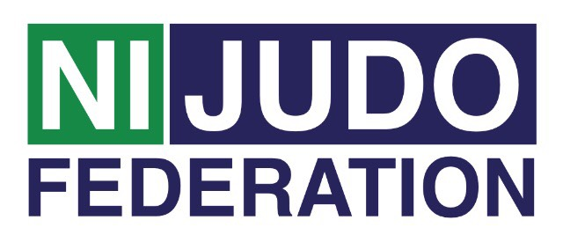
Secretary

Secretary Main role:
♦ Act as Secretary/Minute taker at club committee meetings
♦ Be well aware of all current and future club activities

Tasks involved:
♦ Deal with all correspondence
♦ Support the Chairperson and Treasurer in all aspects of club correspondence
♦ Make arrangements for meetings and prepare agenda in conjunction with Chairperson
♦ Assist the Chairperson to follow the agenda strictly, unless directed otherwise by the
meeting
♦ Take minutes and circulate to all relevant parties as soon as possible after the
meeting. Ensuring all voting issues are recorded accurately.
♦ Preparation and maintenance of records such as Minutes of Meetings, AGM Reports,
etc.
♦ Liaises with the other club members, parents, volunteers etc..
♦ Assist in driving the club development plan forward
♦ To disseminate any information from the National Governing Body and Governing Body to all members

Accountability:
♦ The secretary is accountable to all the members of the club committee

Support and training:
♦ The Northern Ireland Judo Federation Volunteer Co-ordinator will be available to
provide support to all volunteers. This can be on a formal or informal basis as required.

Expenses and equipment:
♦ This is a voluntary post and therefore no payment will be received, on occasion
mileage may be provided if the volunteer is asked to travel further afield.
♦ The Volunteer Co-Ordinator can advise volunteers on the types of expenses that may
be covered.

Vetting:
As Secretary you more than likely not to have access to children/young people or vulnerable adults within the club as part of your role and therefore an Access NI check (enhanced) will not be required. If you are involved in a coaching role this may change, please check with your club.

