Volunteer Role Description
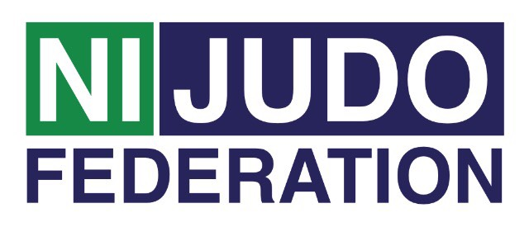
Support Helper
Support Helper Main role:
- To provide support to the coach and participants
- To provide administration activities such as registration
- To help with any other tasks that ensure the smooth running of the session

Tasks involved:
- Assisting the coach/leader to prepare the venue for the session and to clear the venue at the end of the session;
- Encouraging the participants to be active in all activities;
- Following all policies and procedures including the Code of Conduct for Volunteers and supporting the participants to understand the policies and procedures as they apply to them;
- If refreshments are provided – to assist in preparing refreshments and ensuring that the area is cleaned up afterwards;

Time and location:
The club runs weekly on (Insert)……….… from (Insert) until (Insert) at ..(Insert)

Support and training:
- Support Helper will receive support from the coach / leader. Northern Ireland Judo Federation Volunteer Co-ordinator will be available regularly to provide support to all volunteers. This can be on a formal or informal basis as required.
- A variety of training courses will be on offer throughout the year. Some of the courses will be mandatory for all volunteers to attend, such as;
- Volunteer Induction
- Inclusive Training
- Safeguarding Training - Children & Vulnerable adults
- Other courses will be available dependent on the volunteer’s stage of development and requirements for their role.

Expenses and equipment:
- This is a voluntary post and therefore no payment will be received, on occasion mileage may be provided if volunteer is asked to travel further afield.
- The Volunteer Co-Ordinator can advise volunteers on the types of expenses that may be covered.

Vetting:
- Depending on the frequency of this Volunteer Role as Support Helper you may be subjected to a Disclosure & Barring Service (DBS) check as you may be in a regulated position. Information will be provided to you if this is the case.

