Volunteer Role Description
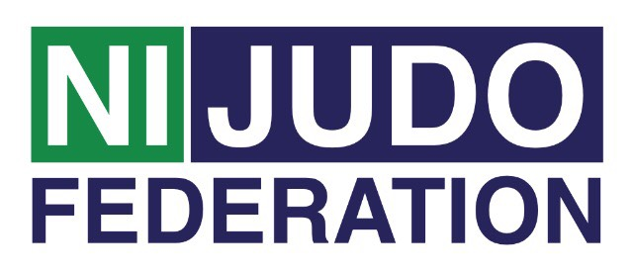
Treasurer
Treasurer Main role:
♦ To ensure that a financial management system and reporting system is put in place
and operable so the club committee has an accurate understanding of the financial
status of the club at all times.

Tasks involved:
♦ Prepare budget to reflect income and expenditure of the club for the clubs Annual General Meeting.
♦ Pay invoices in a timely manner and prioritise payment of accounts.
♦ Maintain appropriate accounts of all income and expenditure.
♦ All monies received to be handed to the Treasurer where a receipt will be issued and, as soon as possible, money to be deposited into Clubs Bank account.

The Treasurer must maintain:
♦ Members’ subscription records
♦ Records of all members which includes contact details, membership type and date club fees paid.
♦ Cash receipts and payments record — Cash receipts are a summary listing of all money received — Cash payments are a summary of all cheque book and cash payments made.

Accountability:
♦ The treasurer is accountable to all the members of the club committee
♦ Ensure all taxation commitments are met by the Club

Support and training:
♦ The Northern Ireland Judo Federation Volunteer Co-ordinator will be available to
provide support to all volunteers. This can be on a formal or informal basis as required.

Expenses and equipment:
♦ This is a voluntary post and therefore no payment will be received, on occasion
mileage may be provided if the volunteer is asked to travel further afield.
♦ The Volunteer Co-Ordinator can advise volunteers on the types of expenses that may
be covered.

Vetting:
As Treasurer you are more than likely not to have access to children/young people or vulnerable adults within the club as part of your role and therefore an Access NI / DBS check (enhanced ) will not be required. If you are involved in a coaching role this may change, please check with your club.

