Volunteer Role Description
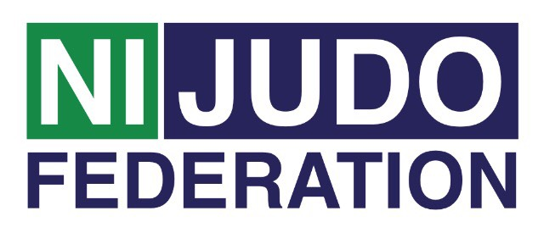
Volunteer Co-Ordinator
Volunteer Co-Ordinator Main role:
- Recruit volunteers into the Judo club
- Retain volunteers within the Judo club by providing support
- Reward volunteers within the Judo club

Tasks involved:
- Assess the needs of the volunteer and match their skills and needs with a role within the judo club
- Monitor and evaluate the volunteers within the club
- Ensure the volunteer is safe in their role, perform risk assessments.
- Ensure the volunteering policy and procedures within the club are up to date
- Generate appropriate volunteering opportunities and role descriptions based on the club
- Ensure there is appropriate support and training for the volunteers taken into your club
- Promote volunteering through your club internally and externally through publicity
- Interview and recruit volunteers and ensure they have the right skills for the role
- Celebrate volunteering by providing awards, and organize celebration events
- Attend club committees to update on volunteering
- Manage club volunteer budget, eg: out of pocket expenses
- Keep up to date with legislation and policy related to volunteering and make any necessary modifications to accommodate changes

Time and location:
The club runs weekly on (Insert)……….… from (Insert) until (Insert) at ..(Insert)

Support and training:
- The Volunteer Co-Ordinator will receive support from the club. Northern Ireland Judo Federation Volunteer Co-ordinator will be available regularly to provide support to all volunteers. This can be on a formal or informal basis as required.
- A variety of training courses will be on offer throughout the year. Some of the courses will be mandatory for all volunteers to attend, such as;
- Volunteer Induction
- Inclusive Training
- Safeguarding Training - Children & Vulnerable adults
- Other courses will be available dependent on the volunteer’s stage of development and requirements for their role.

Expenses and equipment:
- This is a voluntary post and therefore no payment will be received, on occasion mileage may be provided if volunteer is asked to travel further afield.
- The Volunteer Co-Ordinator can advise volunteers on the types of expenses that may be covered.

Vetting:
- Depending on the frequency of this Volunteer Role as Volunteer Co-Ordinator you may be subjected to a Disclosure and Barring Service (DBS) check as you may be in a regulated position. Information will be provided to you if this is the case.

